IDEs are used to develop the applications easily and rapidly
Popular IDEs
- Eclipse
- Intellij
- JDeveloper
- JBuilder
- MyEclipse

Download and Install Eclipse IDE
Google Eclipse IDE install

Developing a Java Application in Eclipse
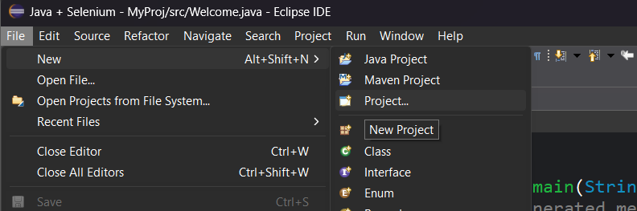
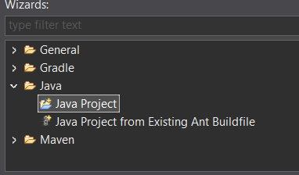
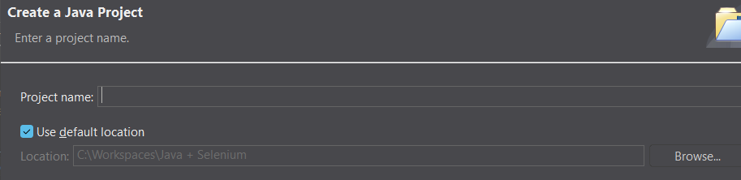
Next > Finish
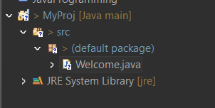

Eclipse Shortcuts
- Public static void main(String[] args){} type main & press ctrl + space + Enter key
- System.out.println(); type sysout & Press ctrl + space
- To Run ctrl + F11
- To Commit single line ctrl + /
- To commit Multiple line select lines & Press ctrl + Shift + /
- To increase font size ctrl + =
- To decrease font size ctrl + -
- To Format the code ctrl + shift + f

Java Basics
- Comments
- Keywords
A keyword is reserved word whose meaning is known to the compiler directly
In Java all keywords are small case letters
Ex.
class, public, static, void, if, else, switch, while, do, for, break, continue, try, catch, private, default etc

- Variables
variable is an identifier which allocates some memory space

- Rules for Identifiers (Var name/ method name / class name)
can contain A-Z, a-z, 0-9, _, $
cannot start with a digit (0-9)
cannot be a keyword

- Valid Identifiers
rollNum
emp_Name
itemNum123
$empSalary

- Invalid Identifiers
Student Name
123rollNum
custNo#
while

- Data Types
Type of data the variable holds is called as data type

Types
- Primitive Data Types
- Reference Data Types

- Primitive Data Types
Type | Size | Default Value | Example
byte | 1 byte | 0 | byte b = 10;
short | 2 bytes | 0 | short s = 100;
int | 4 bytes | 0 | int a = 25;
long | 8 bytes | 0L | long l = 1000L;
float | 4 bytes | 0.0f | float f = 10.5f;
double | 8 bytes | 0.0 | double d = 20.5;
char | 2 bytes | '\u0000' | char c = 'A';
boolean | 1 bit | false | boolean flag = true;

These store actual values directly in memory (stack).

Key Characteristics
- Stored in stack memory
- Store actual value
- Faster access
- Cannot call methods
- Always start with lowercase (int, double)

- Reference Data Types

These store reference (address) of object, not actual data.

Examples:
- String
- Array
- Class (predefined/ user defined)
- Interface
- Object
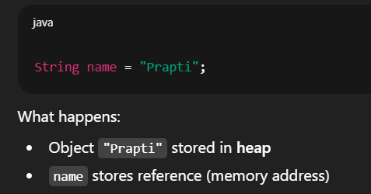
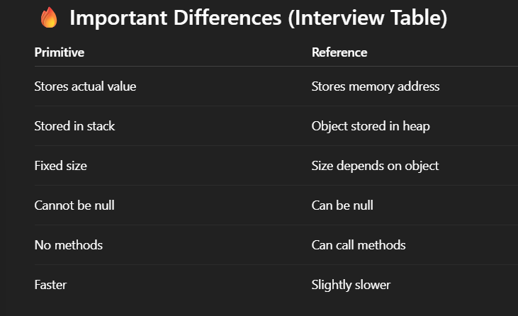

Primitive types store actual values and are allocated in stack memory, whereas reference types store memory addresses of objects created in heap memory.
